Extension Name: To-Do List

Description: A simple To-Do list in which you can add things or tasks that you want to do in near future.

Image:

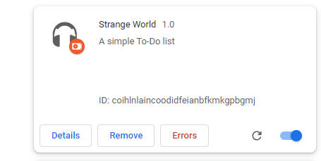

Installation Guide:

1. Go to Chrome settings using three dots on the top right corner.
2. Then Select Extensions.
3. Now,enable developers option.
4. Click on load unpacked and select the folder in which manifest file is contained.
5. The extension will be installed now.